**A CRM APPLICATION FOR LAPTOP RENTALS**

**1. Project Overview:**

This project is dedicated to developing a robust CRM application tailored for managing laptop rentals within a business environment using the Salesforce platform. The primary goal is to tackle operational challenges, including handling rental requests efficiently, monitoring inventory, and facilitating effective communication with customers. Leveraging Salesforce’s strengths in automation, workflow optimization, and data storage, this CRM application aims to:

1. Optimize the Rental Workflow: Streamline the booking and return processes to reduce time and minimize manual intervention required for each rental.

1. Enhance Customer Satisfaction: Send timely email notifications to customers for booking confirmations and return reminders.

1. Increase Data Accuracy and Insightful Reporting: Provide real-time visibility into laptop inventory and rental status, empowering staff to make informed, quick decisions.

**2. Objective Goals:**

1. Streamline the laptop rental and return processes to minimize manual effort, enhancing efficiency and accuracy.

1. Strengthen customer management practices to improve service quality and foster lasting customer relationships.

1. Implement precise tracking and reporting for laptop inventory to ensure accurate availability and effective asset management.

**Specific outcomes:**

* A customized Salesforce CRM application designed to manage rental services with an intuitive interface, allowing users to easily view, manage, and track rental activity.

* Automated workflows streamline the handling of rental requests, provide real-time status updates, and send email notifications.

* Comprehensive reports and dashboards deliver real-time insights into inventory levels, rental activity, and customer engagement.

**3. Salesforce Key Features and Concepts Utilized:**

This section details the core Salesforce functionalities and tools used in the Laptop Rentals CRM application.

* **Custom Objects and Fields:**

**○ Laptop_Bookings__c:** A custom object created to manage each rental booking, featuring fields such as:

■ Customer Name

■ Email__c

■ Amount__c

■ Core__c

■ Laptop_Type__c

■ Status

■ Laptops__c: An additional custom object representing inventory items, which tracks details like model, specifications, and availability status.

* **Apex Triggers and Classes:**

○ Developed an AfterInserttrigger (LaptopBooking) to send automated confirmation emails when a booking is made. The LaptopBookingHandler class formats and personalises these emails with customer details.

* **Process Automation with Process Builder and Flows:**

○ Designed a Process Builder flow to manage booking status changes (e.g., from "Booked" to "In Use" to "Returned") without manual updates.

**● Validation Rules for Data Accuracy:**

○ Added rules to enforce data quality, requiring key fields like Email and Amount for complete booking records.

**● Reports and Dashboards:**

Created dashboards and reports to provide insights on inventory, rental volumes, popular laptop models, and customer demographics, supporting strategic planning and resource allocation.

**4. Detailed Steps to Solution design:**

The solution was carefully designed in multiple steps, covering data models, user - interface, and business logic. Here’s an overview:

**● Data Model Design:**

○ Created Laptop_Bookings__c and Laptops__c custom objects.

○ Established relationships between Laptop_Bookings__c and standard Salesforce objects (Account or Contact) to connect customers with their respective bookings.

○ Additional fields, such as **Email__c, Amount__c, Core__c, and Laptop_Type__c,** are used to store booking-specific data. Relationships between objects are established to link the **Laptop_Bookings__c** object with other standard or custom objects (e.g., Account, Contact) to enhance data integrity and support comprehensive reporting.

Fields Included in the **LaptopBookings** object:

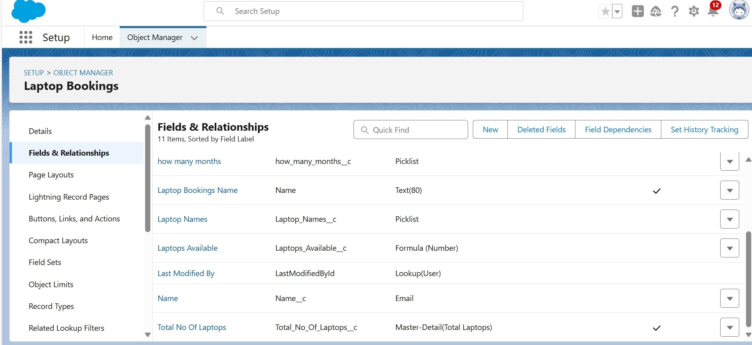

**User Interface (UI) Design:**

The custom Lightning app Laptop Rentals features easy navigation with tabs for key components, including Bookings, Reports, and Dashboards.

■ Configured Page Layouts for Laptop_Bookings__c and Laptops__c with

relevant fields, sections, and related lists for ease of access.

■ Designed dashboards for quick visual insights on active rentals, availability and top-performing laptops.

■ Custom Lightning components may be added to enhance specific sections, such as displaying a chart of most rented laptop models.

**Navigation Items on Laptop Rental Application:**

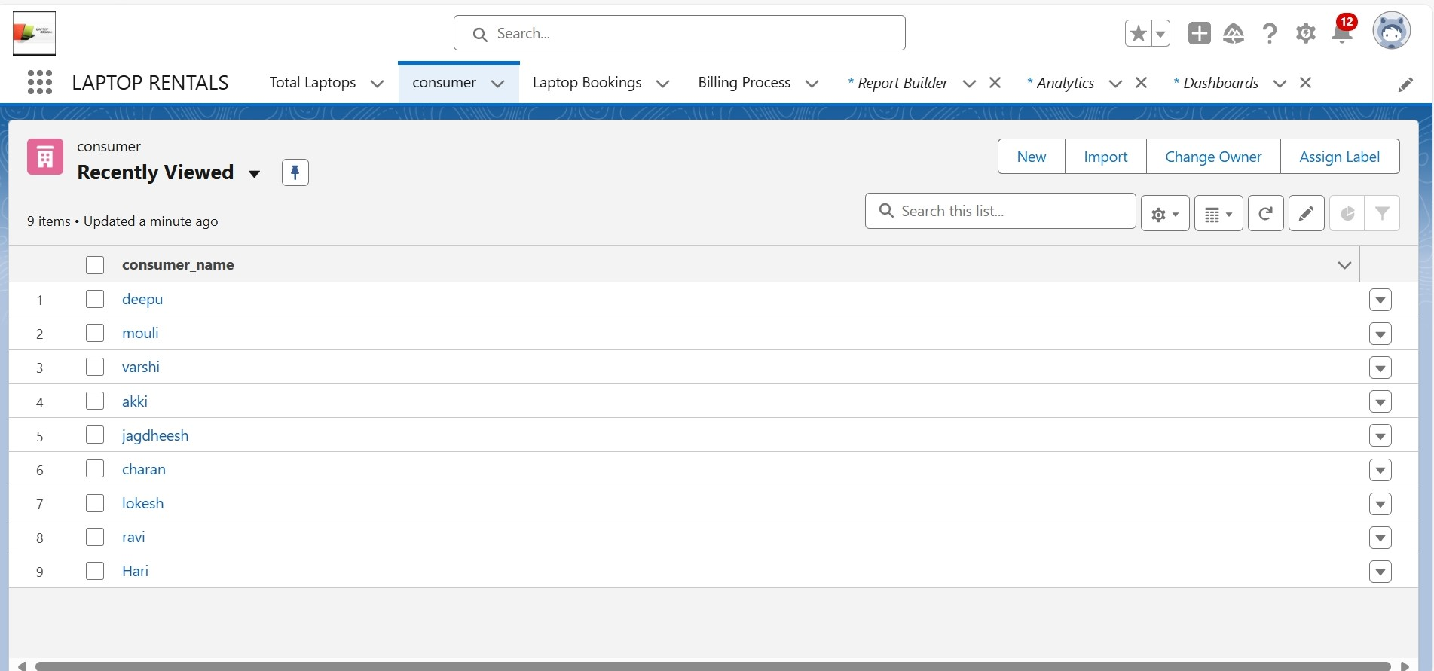

**Business Logic Design:**

○ Developed the LaptopBookingHandler class to handle email notifications using Messaging.SingleEmailMessage.

○ Added the AfterInsert trigger on Laptop_Bookings__c to initiate sendEmailNotification method, ensuring customers receive a welcome and confirmation email after booking.

**Flow Automation:**

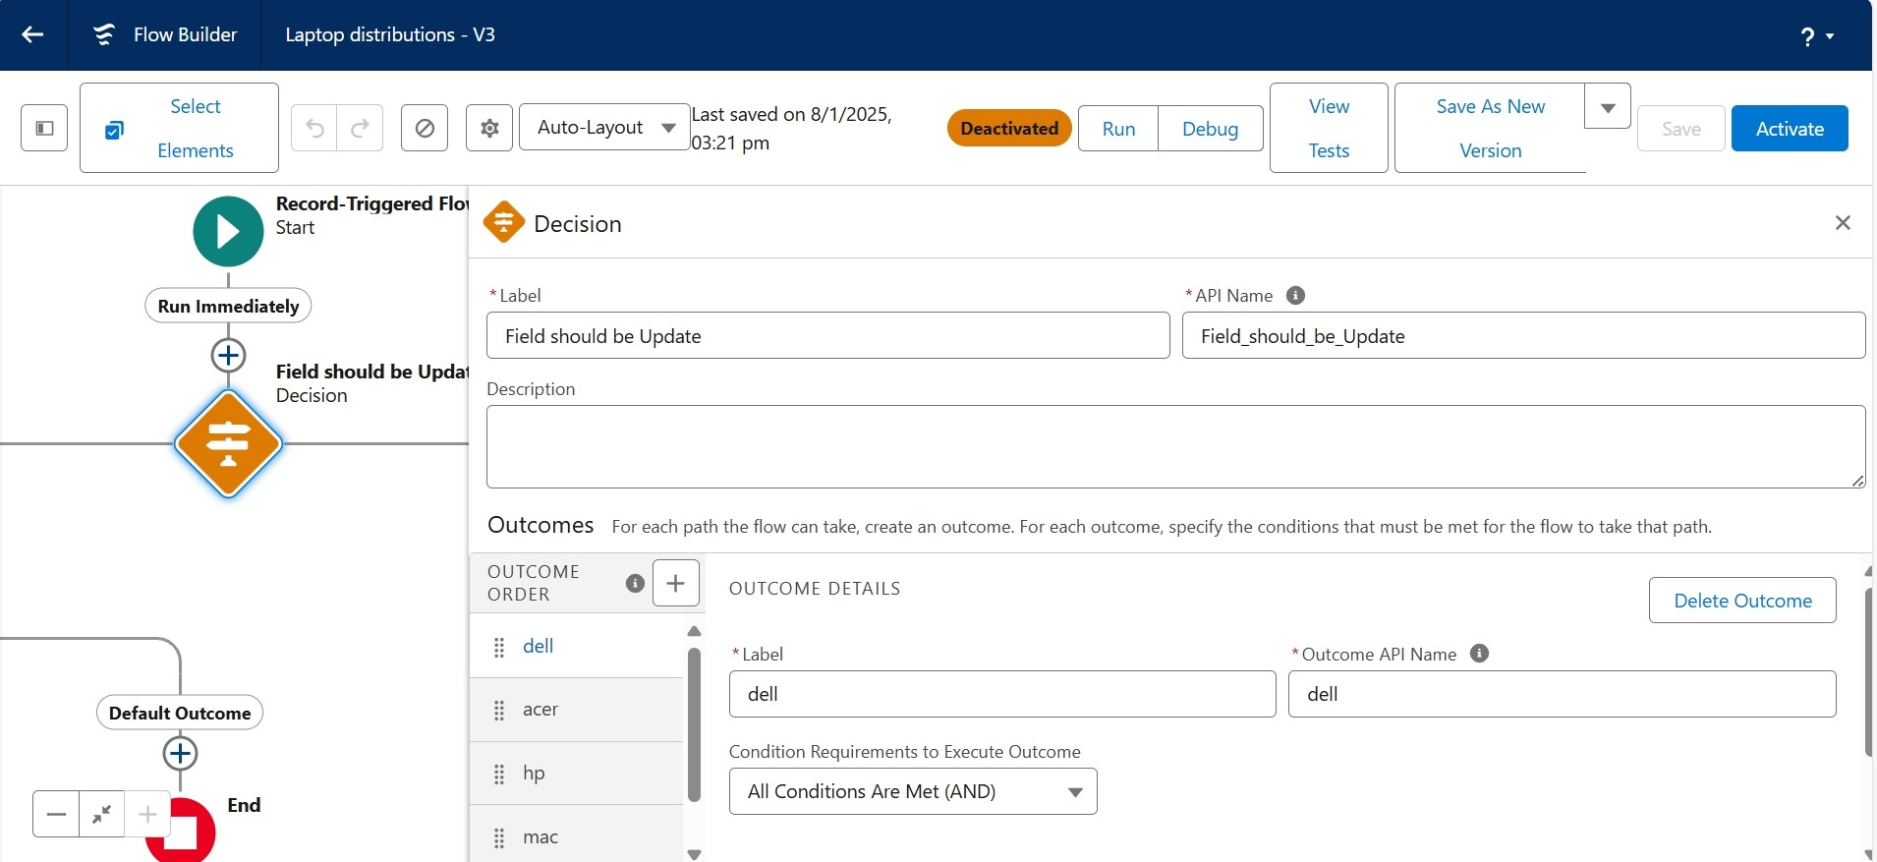

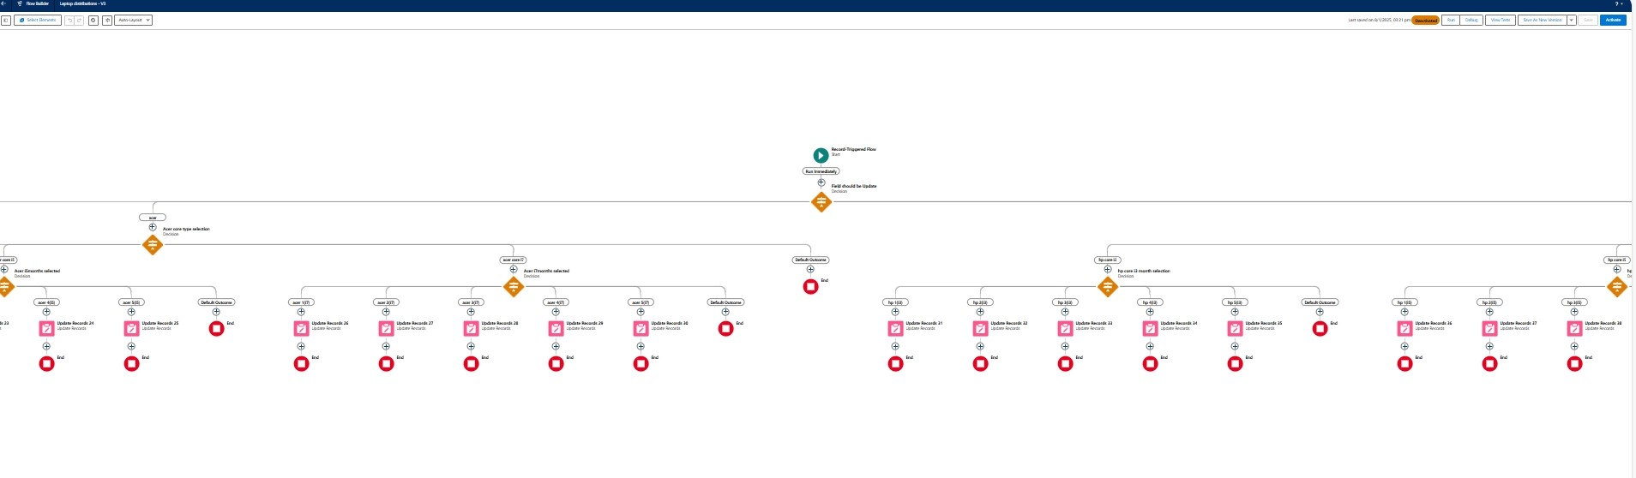

**Validation Rule:**

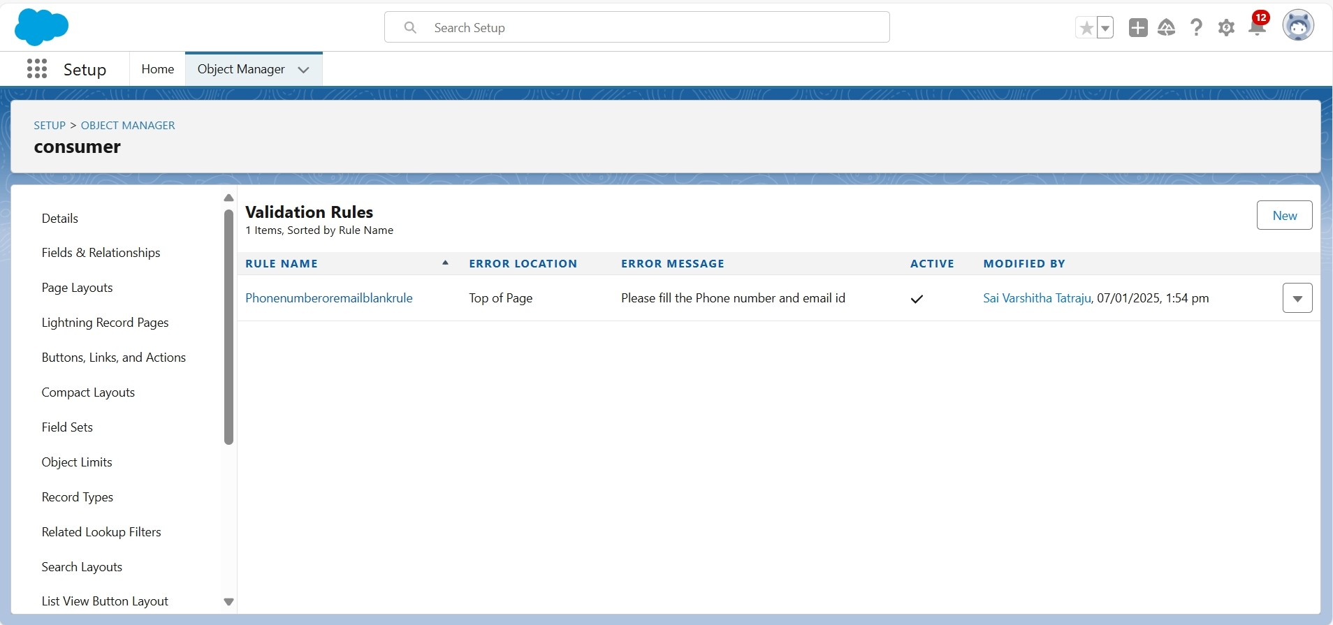

**Conditional Formula:**

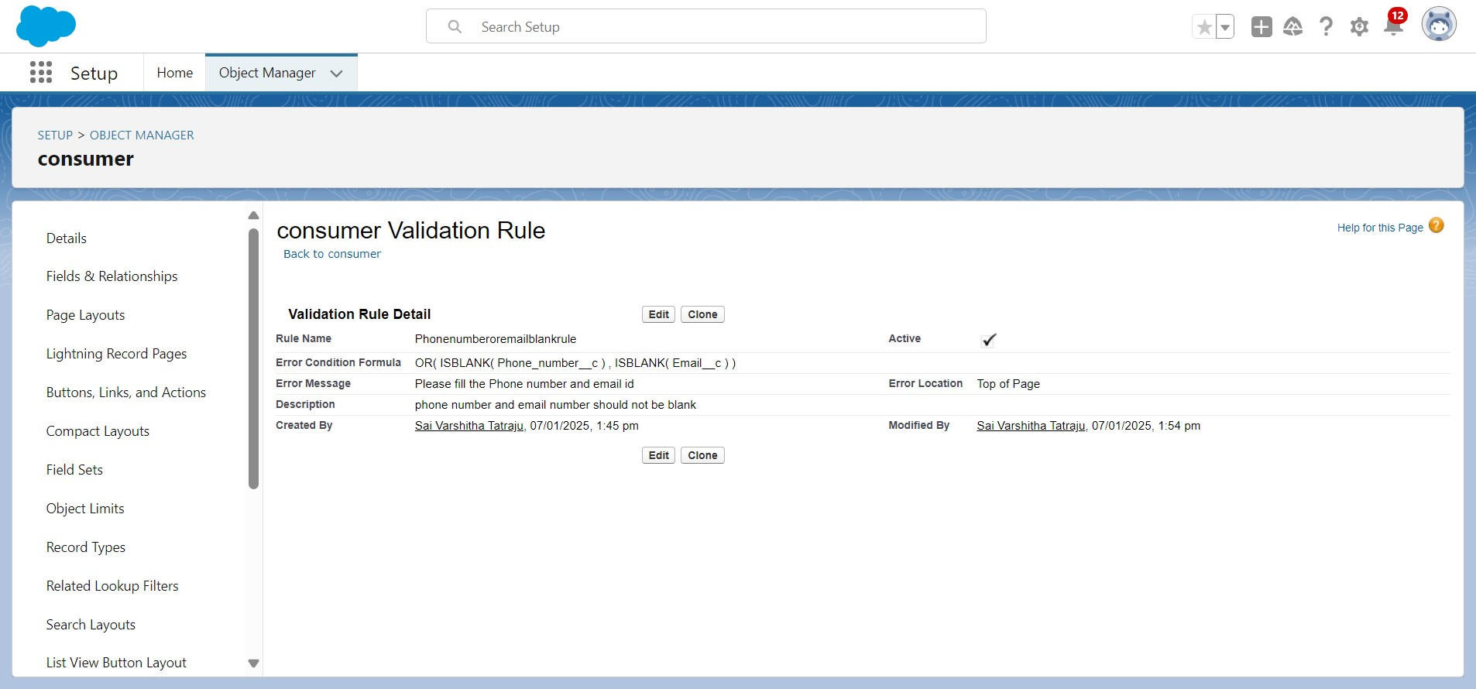

**Apex class:**

Created Apex class with name of **LaptopBookingHandler**

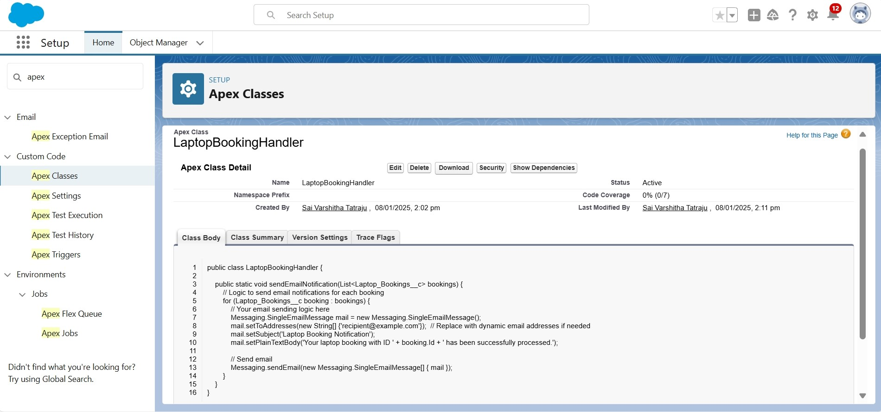

**Apex Triggers:**

Created an APEX Trigger with name of **LaptopBooking**

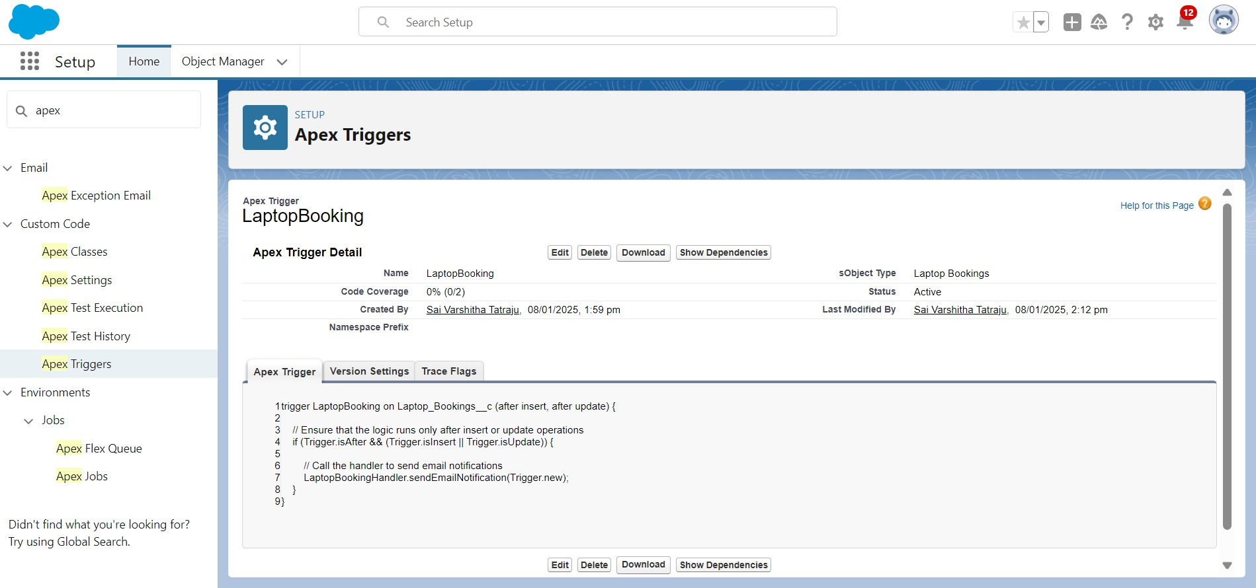

**Reports and Dashboards:**

Reports and dashboards in Salesforce provide valuable insights into the Laptop rentals CRM application,helping the business monitor bookings, revenue, and customer trends effectively.

**Reports:**

* **Tabular Reports:** Used for simple lists, such as a full list of active laptop bookings or consumer records, giving a quick snapshot of data.
* **Summary Reports:** Offers data with grouped subtotals, such as revenue grouped by laptop type, making it easy to identify high performing categories.

**Dashboards:**

* **Revenue Overview:** Shows total rental revenue over time, helping track financial performance.
* **Popular Laptops:** Displays the most rented laptop types, aiding inventory and marketing decisions.
* **Customer Insights:** Provides data on customer types, helping target future marketing campaigns more effectively.

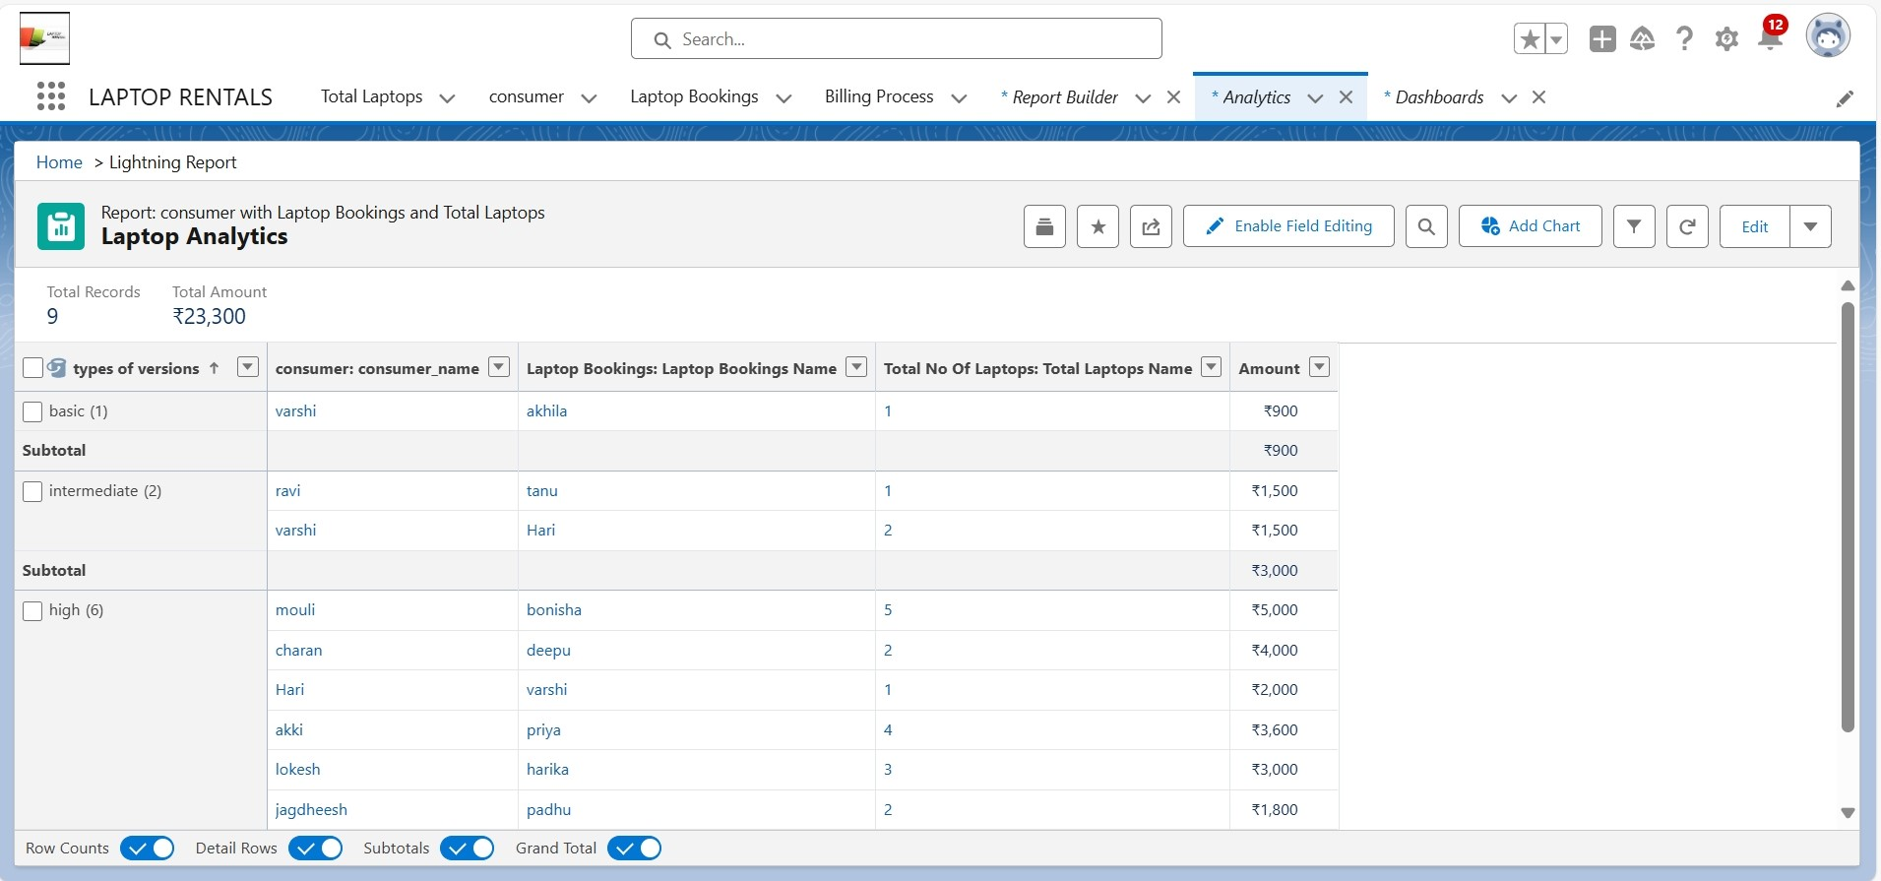

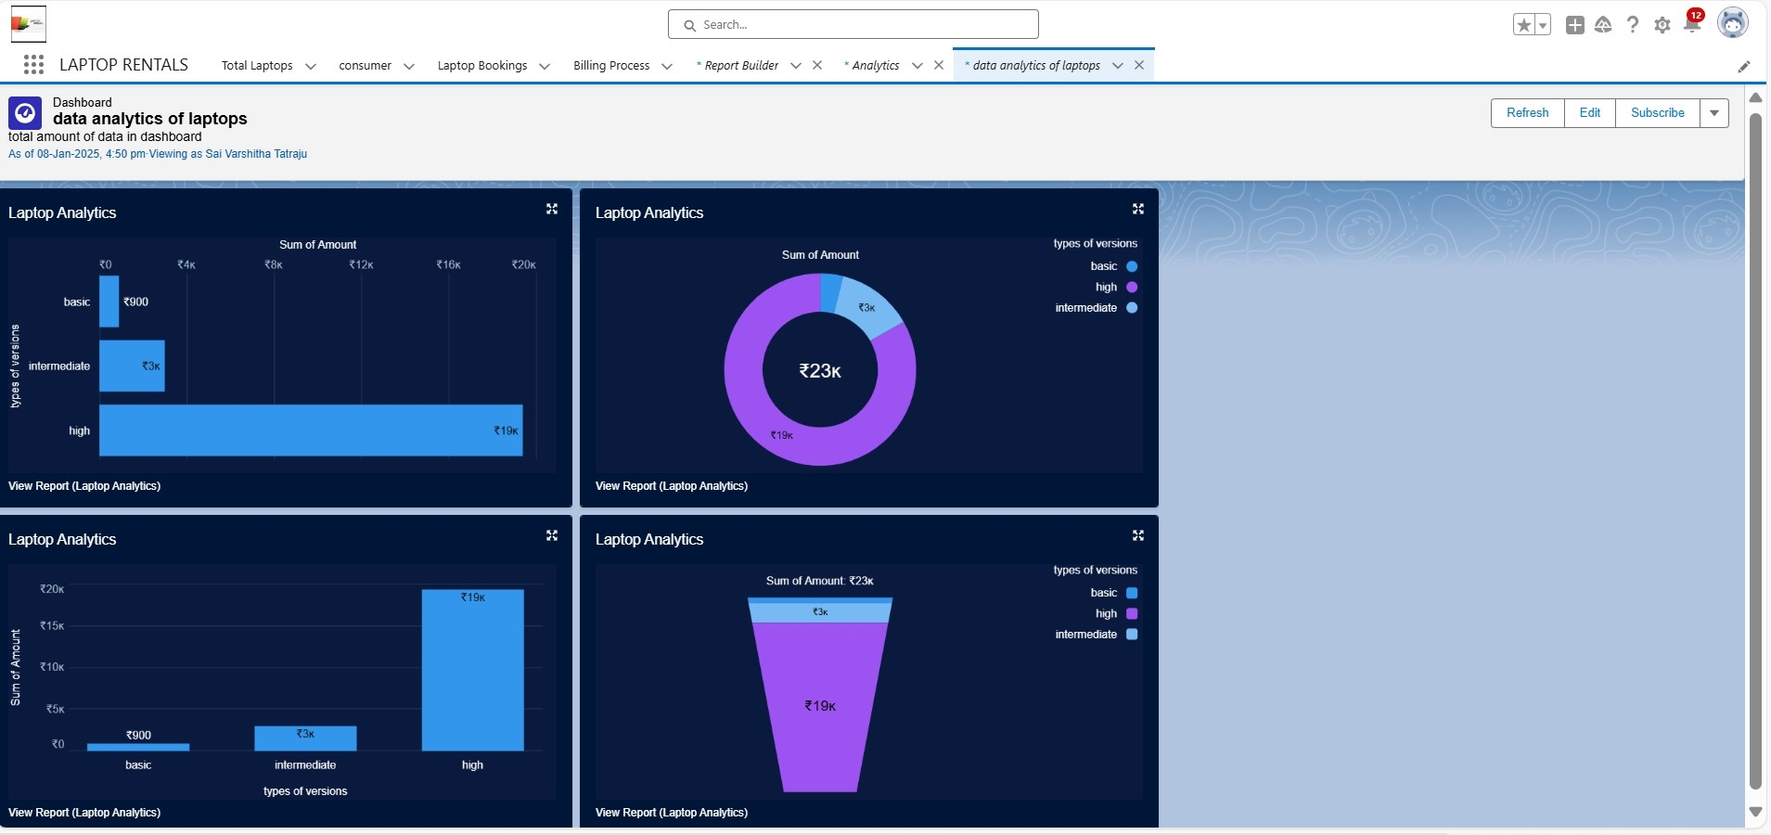

**5. Testing and Validation :**

**● Unit Testing:**

Each Apex class and trigger was thoroughly tested, ensuring at least 75% code coverage. Tests were designed to validate that:

○ Booking confirmation emails are sent correctly.

○ Inventory statuses update accurately.

* **User Interface Testing:**

Verified that the UI elements display correctly on page layouts and that all required fields and related lists are accessible. Ensured users could access only the fields allowed by their profile permissions.

* **Test Scenarios:**

**○ Scenario 1:** Create a new booking and verify that an email is sent with the correct booking details.

**○ Scenario 2:** Check that validation rules enforce required fields like Email__c and Amount__c.

**○ Scenario 3:** Test that inventory adjusts automatically when a booking status is changed from "Booked" to "Returned."

**6. Key Scenarios Addressed by Salesforce in the Implementation Project :**

This project addresses several critical scenarios to ensure a smooth rental experience for both customers and staff:

**○ Automated_Notifications:** Automatically send confirmation emails when a booking is created and provide status updates as the rental progresses. This keeps customers informed and reduces the workload for staff.

**○ Real-Time_Inventory_Management:** Track the availability of laptops in real time, updating inventory counts when laptops are rented and returned.

**○ Workflow_Automation_for_Booking_Lifecycle:** Manage booking statuses with automation, moving each booking from "Booked" to "In Use" and finally "Returned" without manual intervention.

**○ Role-Based_Data_Access:**  Define roles and permissions, allowing staff to manage bookings and customers, while customers can only access their rental information.

**7. Conclusion:**

The Laptop Rentals CRM application demonstrates an effective use of Salesforce to automate and manage key rental business processes. Leveraging custom objects, Apex programming, and flow automation, the project streamlines data management and enhances customer interactions. Key features like email notifications, dynamic pricing, and streamlined booking processes have improved both customer experience and operational efficiency.

Salesforce's reporting and dashboard tools offer valuable insights into rental trends, revenue tracking, and decision-making. With validation rules and role-based access, the solution ensures data security and integrity, supporting sustainable business growth. This project not only meets immediate objectives but also establishes a scalable foundation for future enhancements, positioning Laptop

Rentals for long-term success in customer satisfaction and operational efficiency.